Tasks

# Objective Questions:

1. What is the total no. of tables present in the data? Ans: **2 tables** present in the given data.

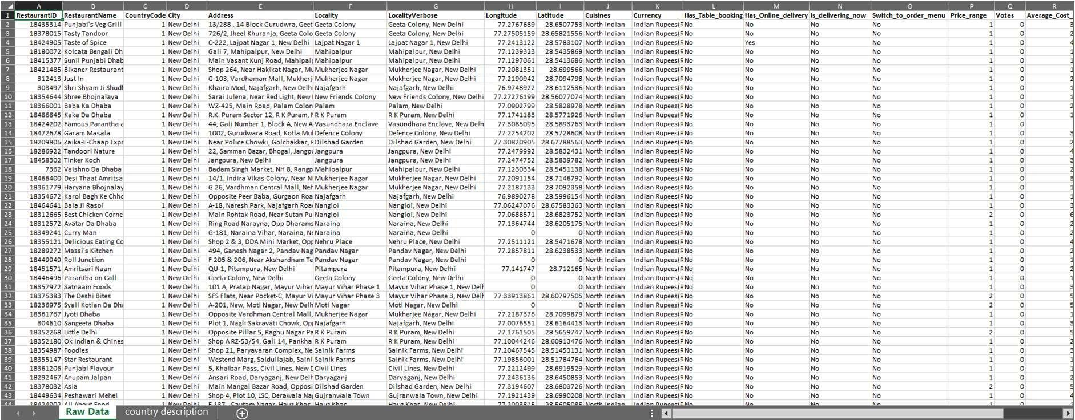

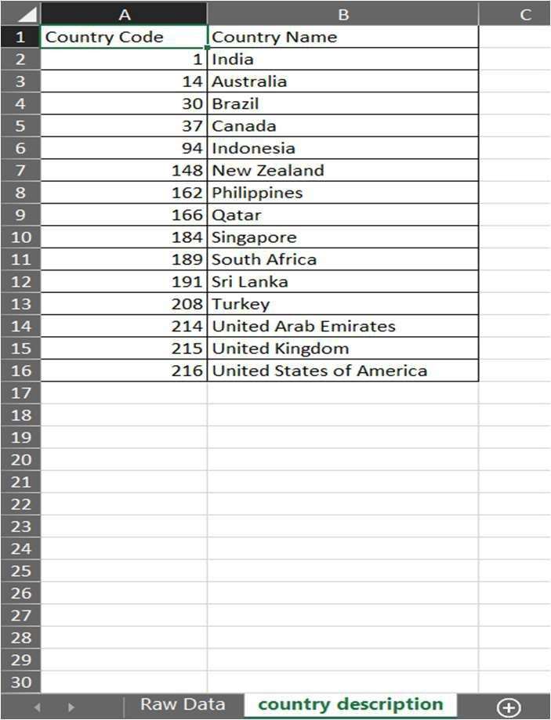

1. What is the total no. of attributes present in the data? Ans:
   * **20** attributes in **‘Raw Data’**
   * **2** attributes in **‘country description’**



1. How many categorical columns are there in the data? [Search about categorical and continuous data, and try to answer this question]

Ans : **19** Categorical columns



1. The data consists of some inconsistent and missing values so ensure that the data used for further analysis is cleaned.

Ans:

* + Go to Data -> Remove Duplicates.
  + Then, there will be a dialog box asking to select the columns of the table and mainly we have to tick the **’My data has headers’** check box.
  + Then Click OK.
  + The rows with duplicate values would be removed.
  + If there are no duplicate values, a dialog box will be displayed mentioning **“No duplicate values found.”**

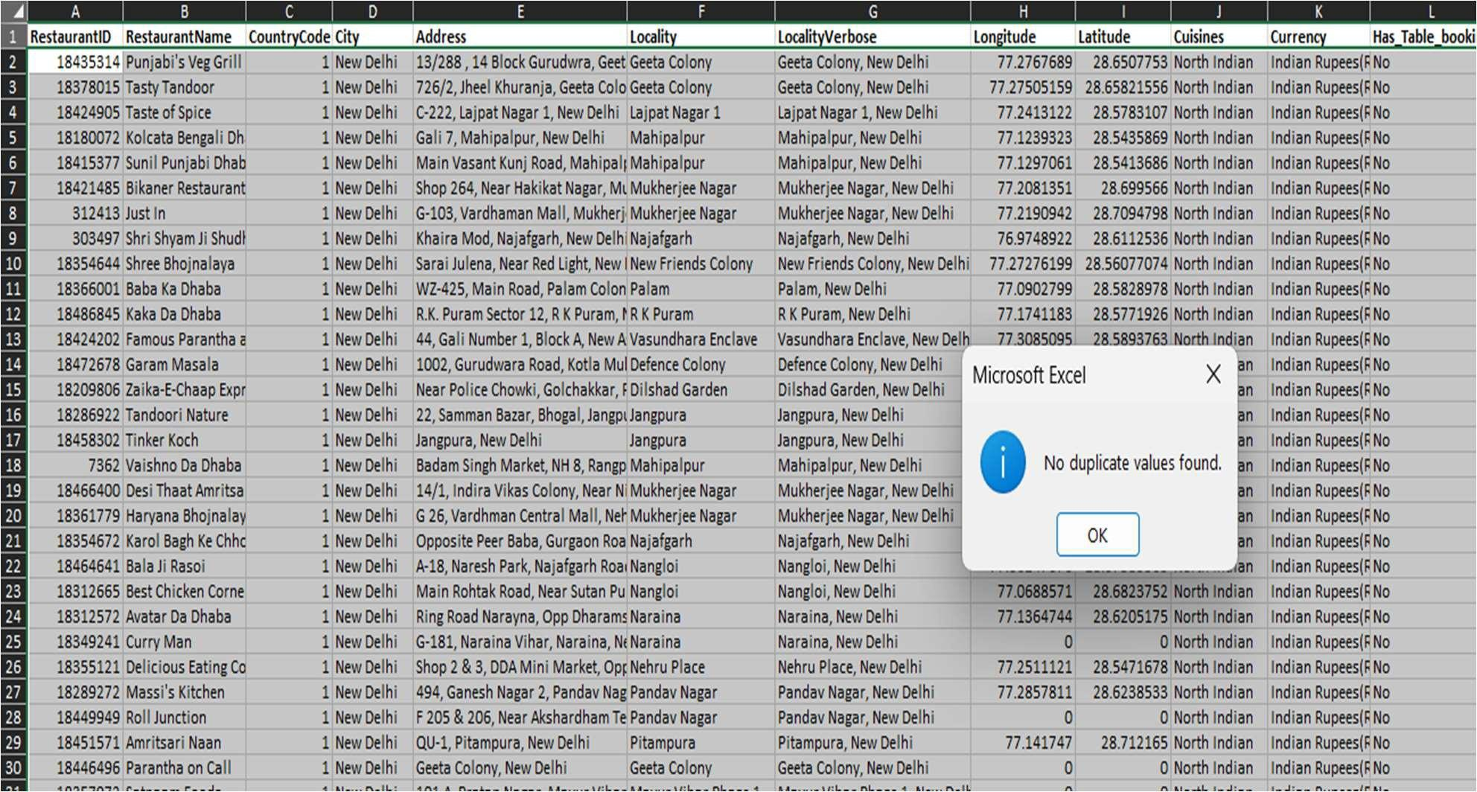

* + Check for any missing values using COUNTBLANK(Cell Range).
  + Use the function **=COUNTBLANK(‘Raw Data’!A1:V9552)** to find the count of blank values in the specified range as shown in diagram below:

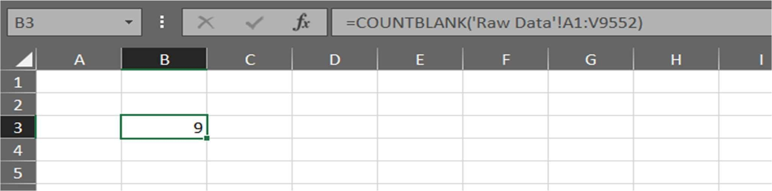

* + Filter the blank values from the column where the values are missing.

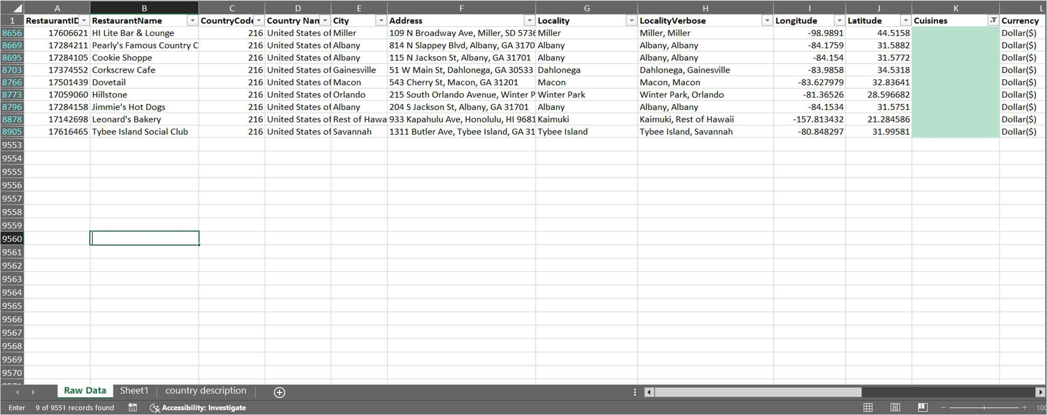

* + Create a Pivot table to check the most number of occurring cuisines

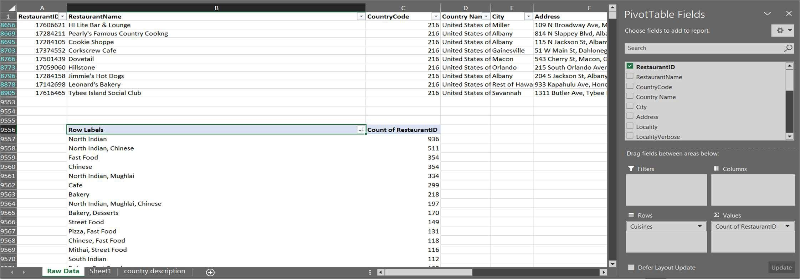

* + Replace it in place of the blank values. Most occurring value (**North Indian – 936 times)**

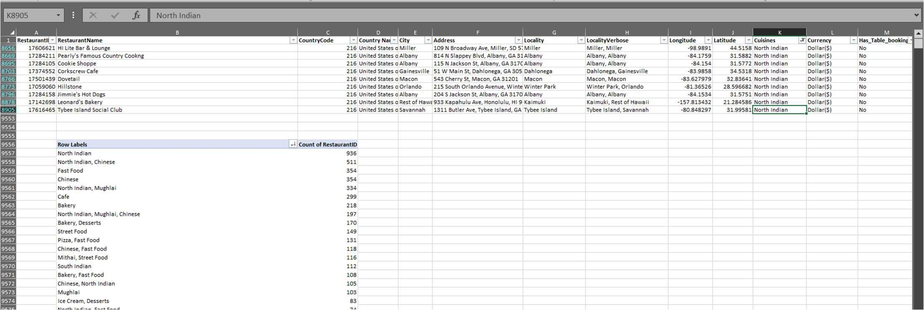

1. Using the LookUp functions, fill up the countries in the original data using the country code. Ans: =**VLOOKUP(C2,'country description'!$A$1:$B$16,2,0)**
   * The country code is present in C column.
   * So, Insert a column near the country code and name it as Country Name.
   * The country code and country name is present in another worksheet named **‘country description’**
   * Use the lookup Formula =**VLOOKUP(C2,'country description'!$A$1:$B$16,2,0)** to lookup for values from country_description worksheet and display values for Country Name in the **‘Raw Data’** worksheet

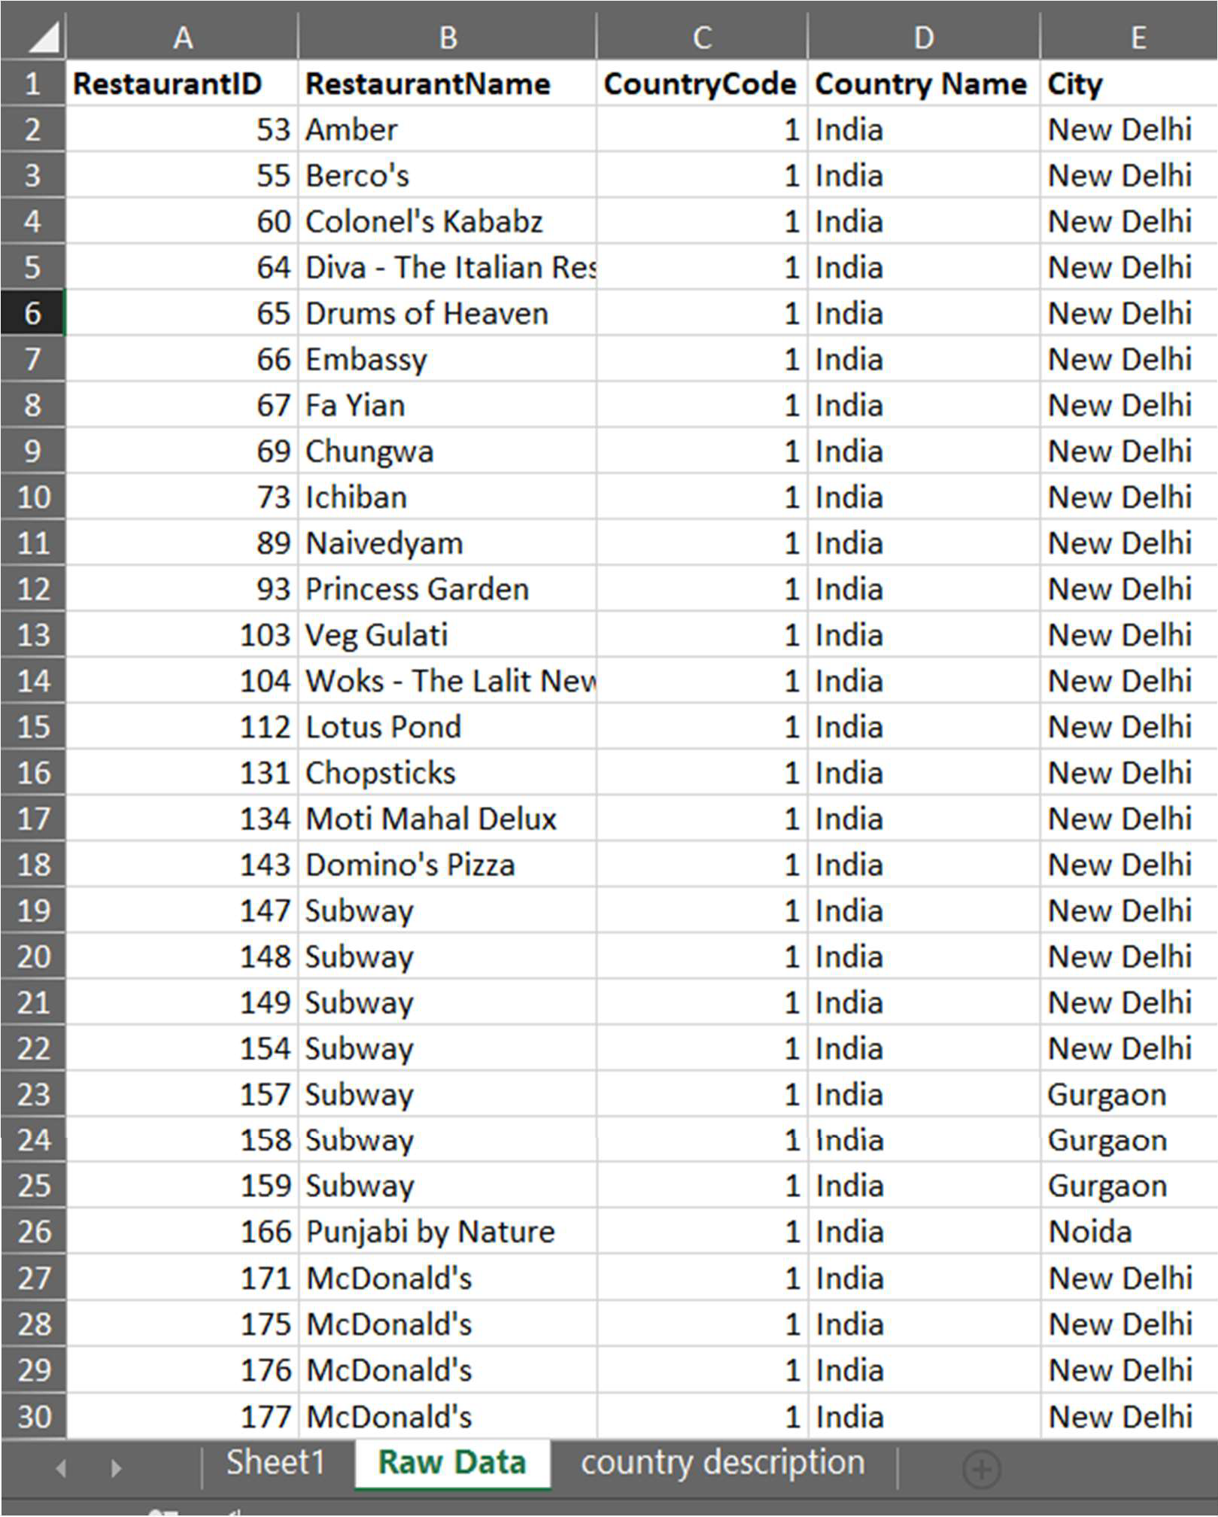



1. Create a table to represent the number of restaurants opened in each country.

Ans:

* + Select the whole table range.
  + Click on **Insert -> Pivot Table**.
  + In the PivotTable Fields dialog box, Place **‘Country Name’** in **Rows** and **‘Restaurant ID’** under **‘Values’**.
  + Change the aggregate function of **‘Restaurant ID’** to **‘Count’** and Rename the column to Number (Count) of Restaurants for better understanding.

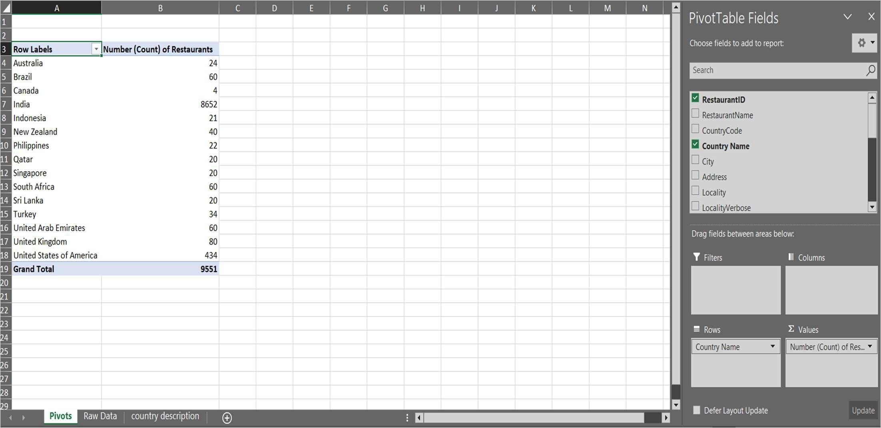



1. Also, the management wants to look at the number of restaurants opened each year, so provide them with something here.

Ans:

* + Replace **‘_’** with **‘–‘** in the datekey_opening column to convert the values to date format.
  + Use **YEAR()** function to extract Year from datekey_joining and name the column as

## ‘Year of Opening’.

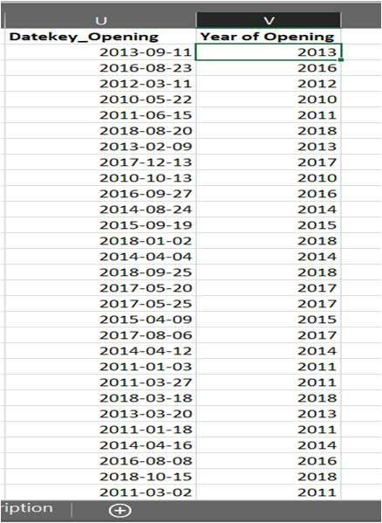

* + Select the whole table range.
  + Click on **Insert -> Pivot Table**.
  + In the PivotTable Fields dialog box, Place **‘Year of Opening’** in **Rows** and **‘Restaurant ID’** under **‘Values’**.
  + Change the aggregate function of **‘Restaurant ID’** to **‘Count’** and Rename the column to Number (Count) of Restaurants for better understanding.

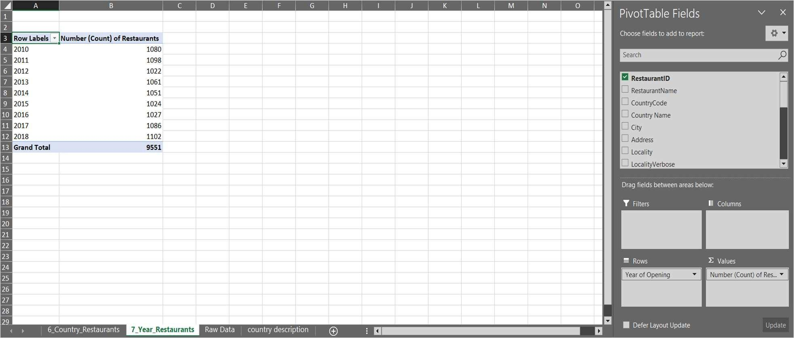

1. What is the total number of restaurants in India in the price range of 4? Ans: **=COUNTIFS('Raw Data'!D:D, "India", 'Raw Data'!Q:Q,4)**
   * **388** restaurants in India with Price Range of 4.
   * 2 conditions to be selected where criteria_range1 is Country Name (Column D) and the criteria1 is “India”. Similarly criteria 2 is Price Range (Column C) and the criteria2 is 4.

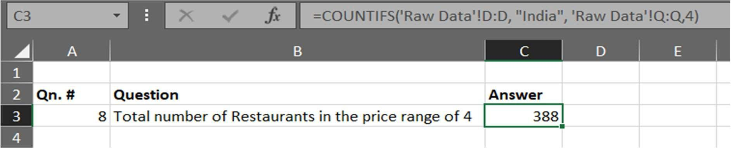



1. What is the average number of voters for the restaurants in each country according to the data?

Ans:

* + Select the whole table range.
  + Click on **Insert -> Pivot Table**.
  + In the PivotTable Fields dialog box, Place **‘Country Name’** in **Rows** and **‘Votes’** under

## ‘Values’.

* + Change the aggregate function of **‘Votes’** to **‘Average**’ and Rename the column to Average Number of Voters in each Country for better understanding.

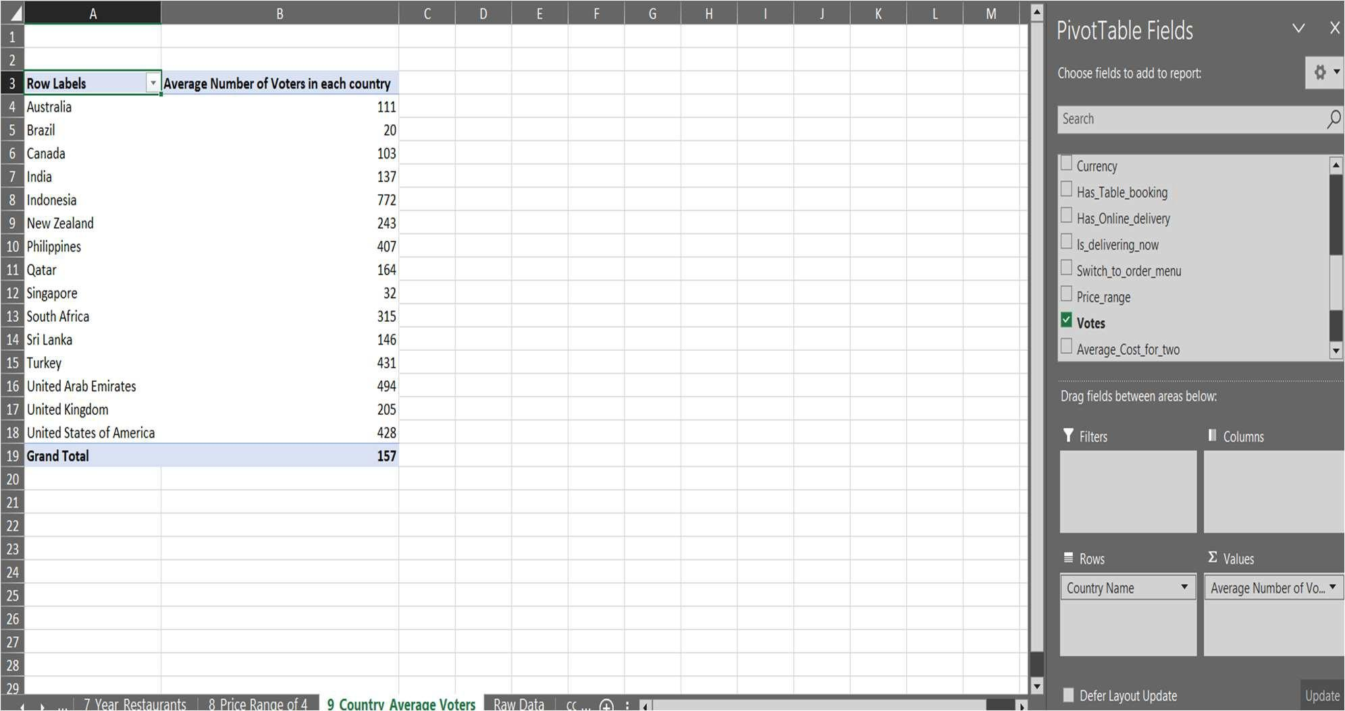



1. Calculate the average rating for all the restaurants that have price_range < 4 and provide online delivery. Use only the “IF” function, Logical Operators, and Aggregation functions to solve this problem. **[Note: Don’t use Conditional aggregation in this question.]**

## Ans: = SUM('Raw Data'!R2:R9552) / COUNT('Raw Data'!R2:R9552)

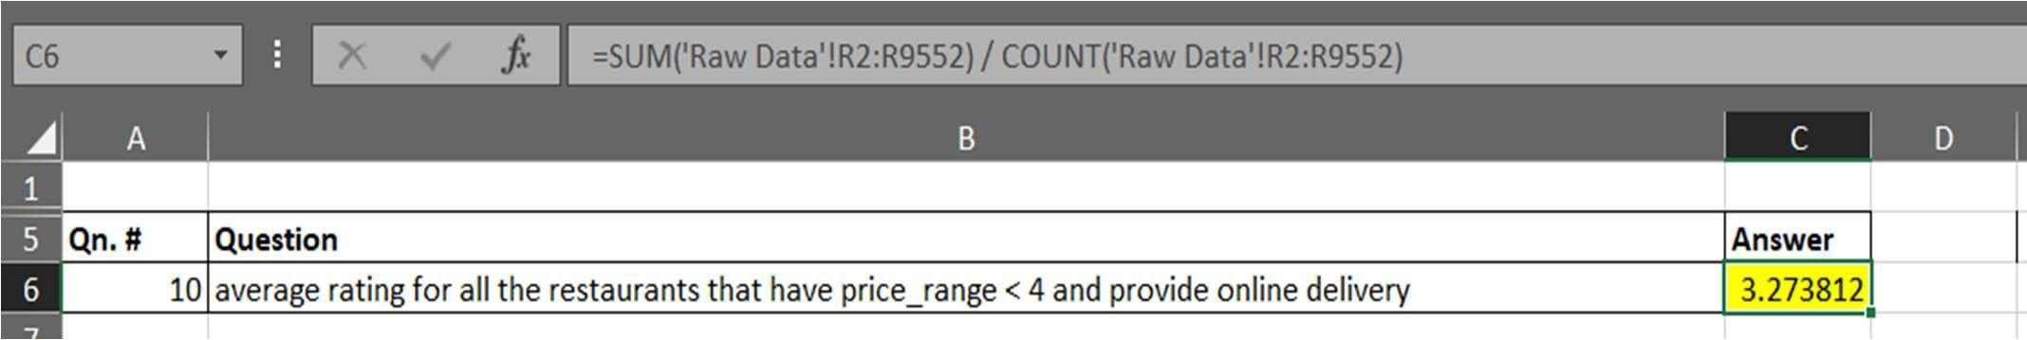

Before the previous step,we check both the conditions using IF, AND. If both the conditions are

* + True, Display the rating in Column R
  + False, the rating value will be blank

## Column R in Raw Data Table = IF(AND(Q2<4, N2="Yes"), W2, "")

where

* + Column Q = Price Range (Q2<4)
  + Column N = Has Online Delivery (N2=”Yes”)
  + Column W = Rating

Using the Fill Handle option, the formula will be applied to all the rows in the column R.

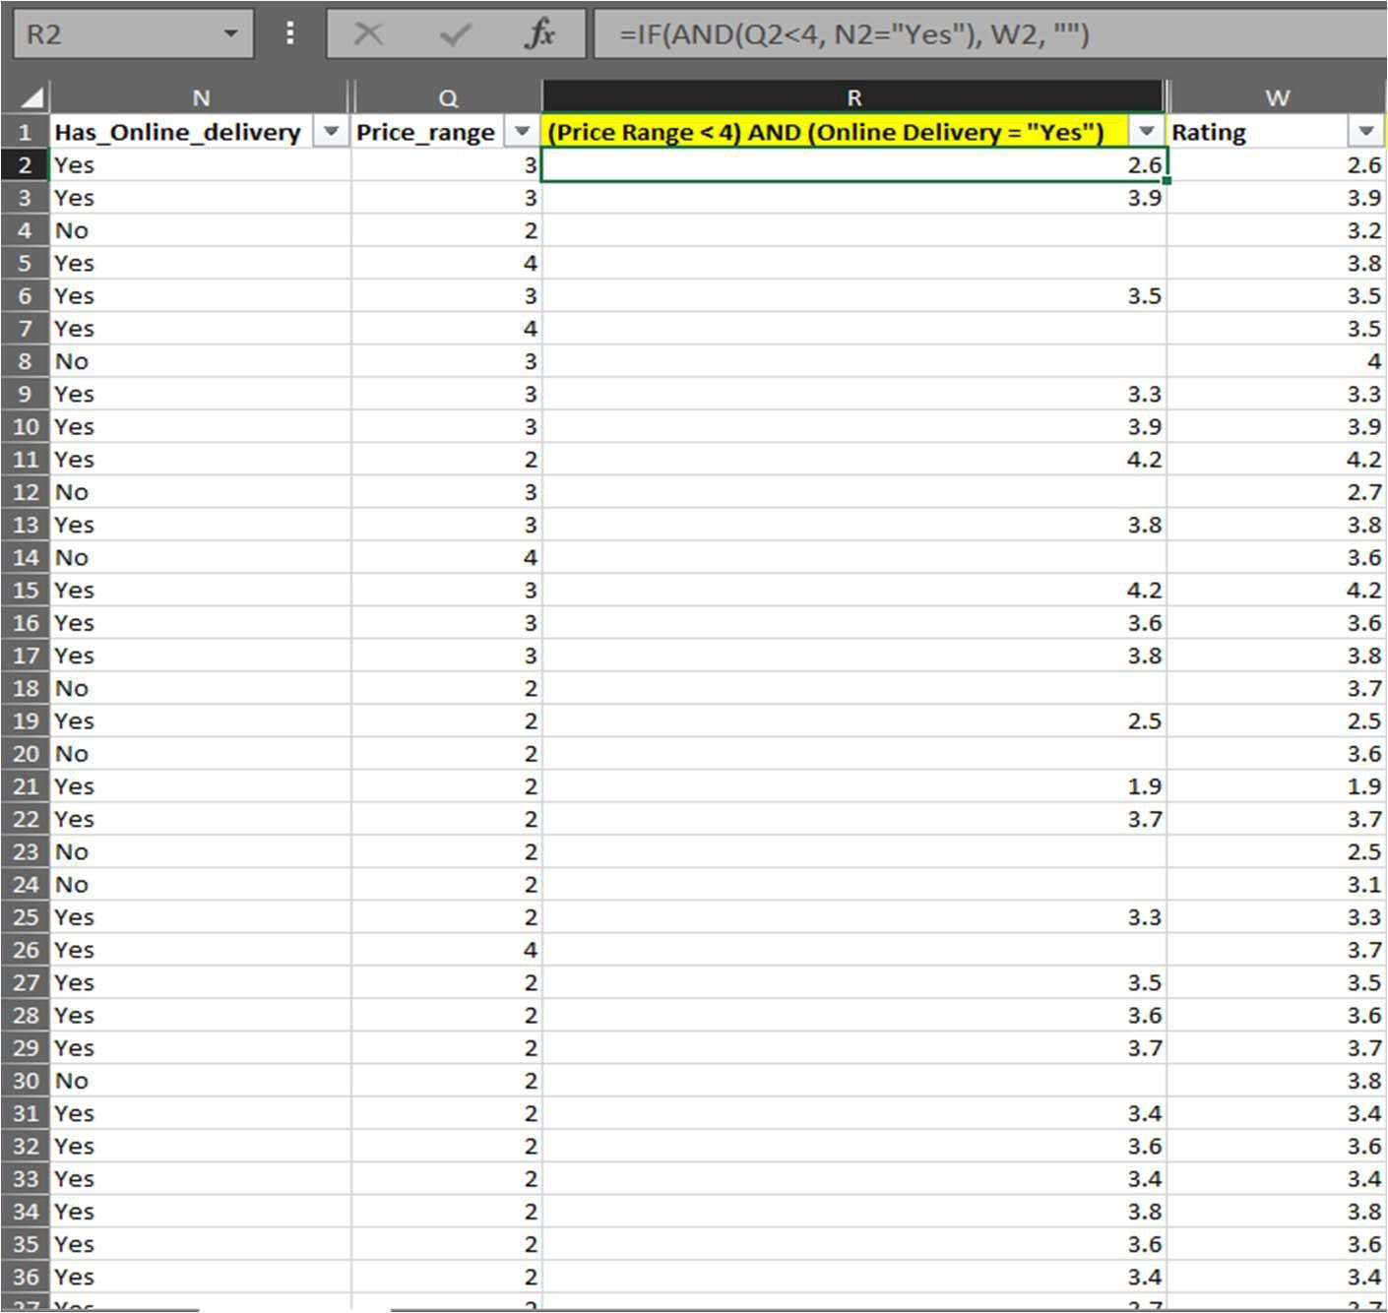



1. Using Conditional formatting highlights the rows of restaurants that are located in the countries or cities that you’ve suggested to the management for opening new restaurants. [Highlighting columns is enough]

Ans: 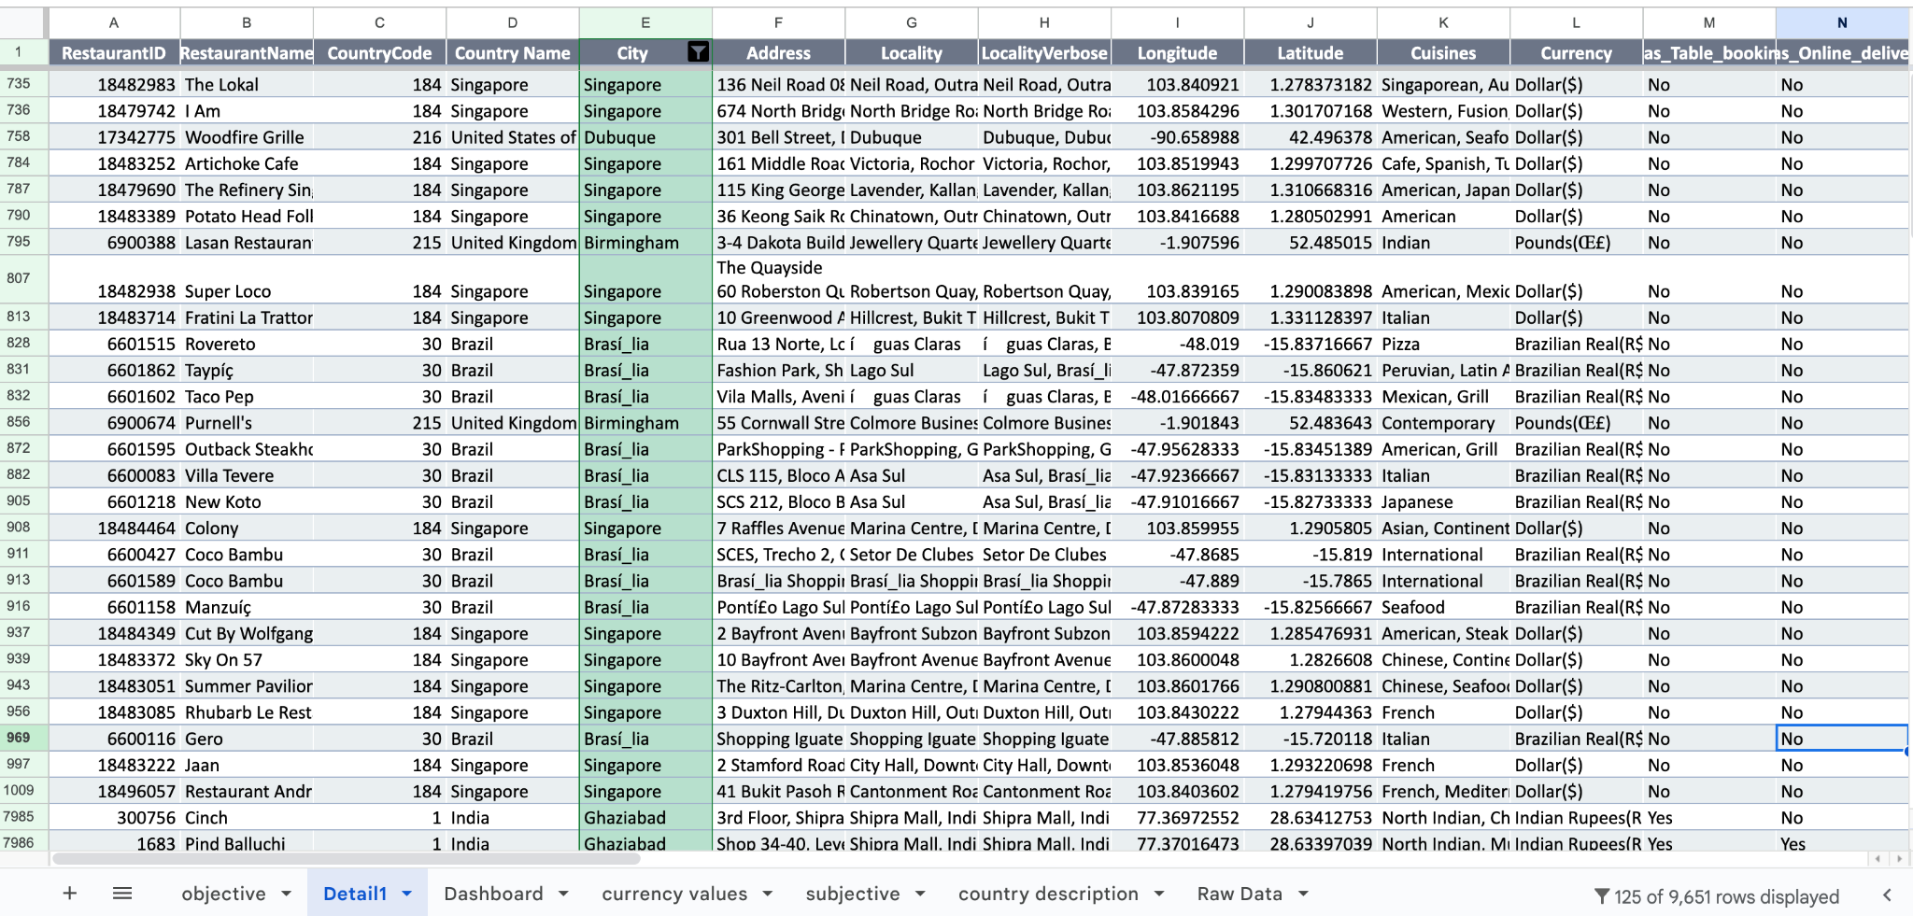

The suggested cities to open new restaurants have been highlighted in the above picture.



1. Create a new customized price column that consists of the abbreviation/symbol of the currency along with the Average_cost_for_two value. [Use string operations to do this task]

## Ans: =CONCATENATE(MID(LEFT(L2,LEN(L2)-1),FIND("(",L2)+1,99), " ", T2)

* + Column L contains **Currency**
  + Column T contains **Average_Cost_for_two**
  + MID(LEFT(L2,LEN(L2)-1),FIND("(",L2)+1,99) extracts the Currency symbols between the parantheses ().
  + CONCATENATE() – To merge the Columns L and T to display the Currency along with Average_cost_for_two (Column V)

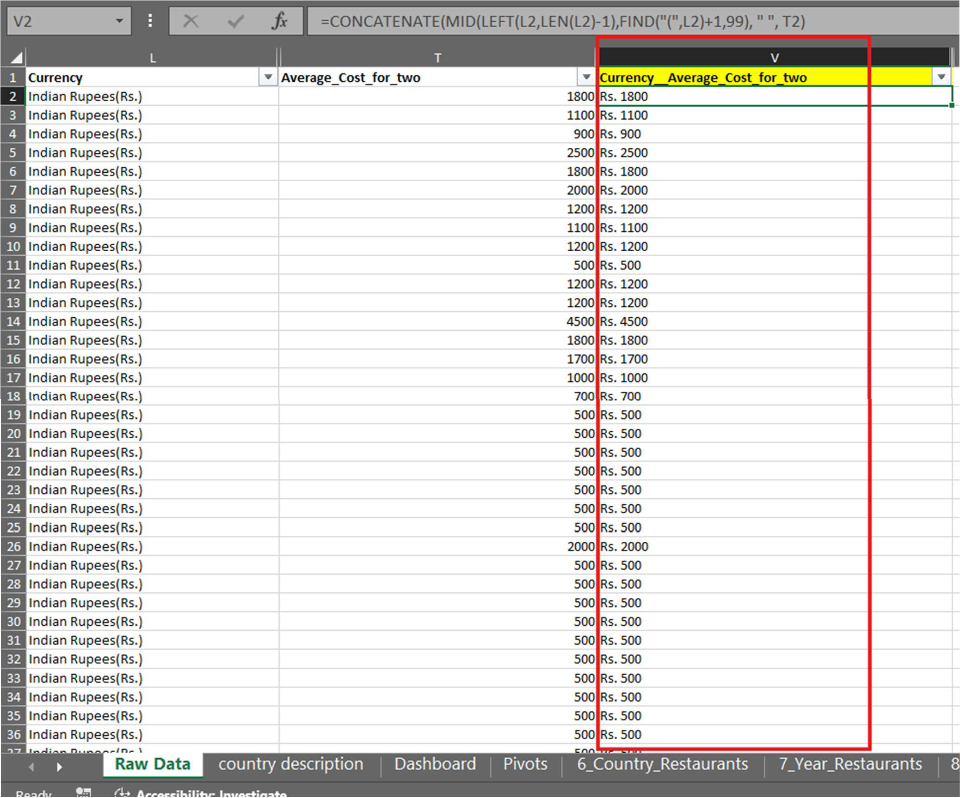



1. How can you create an array formula in Excel or Google Sheets to count the number of restaurants listed that do not offer online delivery, are in the lowest price range, and have an average cost for two people less than or equal to 250 Indian Rupees?

Ans: **1694**

## Formula : {= COUNTIFS('Raw Data'!N2:N9552 , "No", 'Raw Data'!Q2:Q9552, 1, 'Raw Data'!T2:T9552,"<=250")}

* + Array formula is enclosed in {} (Curly Braces)

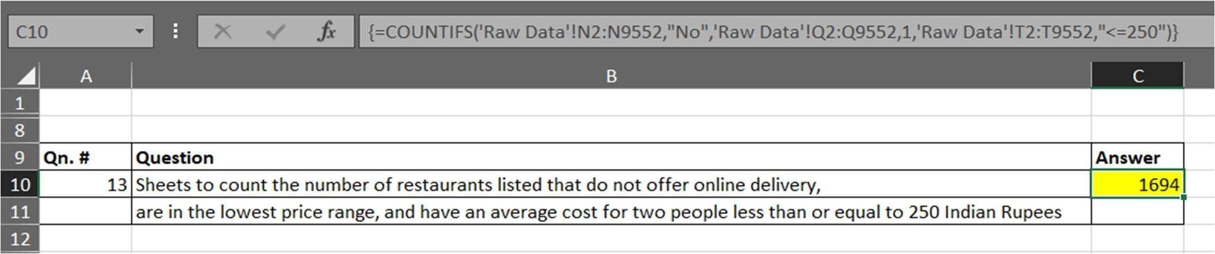

# Subjective Question:

1. Suggest a few countries where the team can open newer restaurants with lesser competition. Which visualization/technique will you use here to justify the suggestions?

Ans:

* + New restaurants can be opened in countries like Brazil, Singapore, Sri Lanka, United Kingdom, United States of America and India where the average ratings are between 2 and 3 out of 5.
  + Also, the average cost per two people ranges from 600 INR (India) to 9850 (INR) in Singapore, which would be a good idea to open new restaurants as the ranges of prices in these countries is diverse.

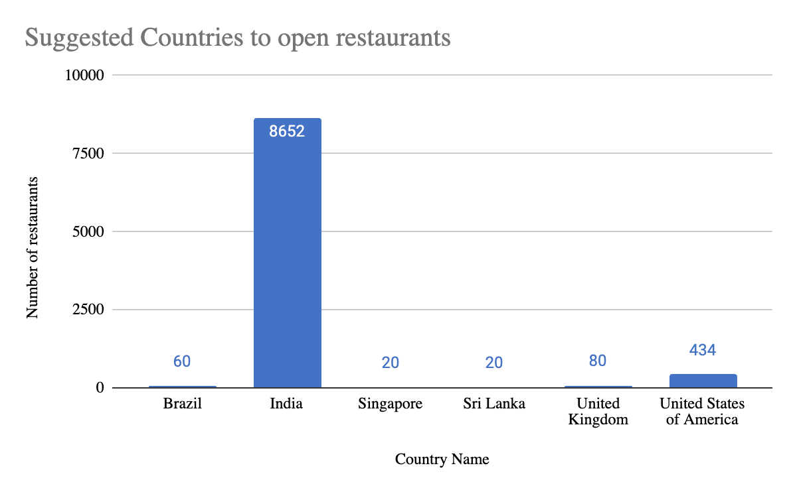

## Recommendation:

* While opening restaurants in these cities, various factors such as average rating, average cost for two, cuisines should be considered.



1. Come up with the names of States and cities in the suggested countries suitable for opening restaurants.

Ans:

* + Brasí_lia, Brazil
  + Ghaziabad, India
  + Singapore, Singapore
  + Colombo, Sri Lanka
  + Birmingham, United Kingdom
  + Dubuque, United States of America

| *Country Name* | *City* | AVERAGE of average cost for two(in Indian Rupees) | AVERAGE of Rating | COUNTA of RestaurantName | AVERAGE of Average_Cost_for_two |
| --- | --- | --- | --- | --- | --- |
| Brazil | Brasí_lia | 1791.6 | 3.545 | 20 | 120 |
| India | Ghaziabad | 602 | 2.932 | 25 | 602 |
| Singapore | Singapore | 9849.63 | 3.575 | 20 | 155.75 |
| Sri Lanka | Colombo | 665 | 3.87 | 20 | 2375 |
| United Kingdom | Birmingham | 4165.98 | 3.73 | 20 | 39 |
| United States of America | Dubuque | 1993.8125 | 3.535 | 20 | 23.75 |
| **Grand Total** |  | **3074.9636** | **3.5072** | **125** | **554.56** |

## Recommendation:

While opening restaurants in these cities, various factors such as average rating, average cost for two, cuisines with respect to the restaurants in those cities should be considered.



1. According to the countries you suggested, what is the current quality regarding ratings for restaurants that are open there?

Ans:

| **City, Country** | **No. of Restaurants** | **Average Rating** |
| --- | --- | --- |
| Brasí_lia, Brazil | 20 | 3.55 |
| Ghaziabad, India | 25 | 2.93 |
| Singapore, Singapore | 20 | 3.58 |
| Colombo, Sri Lanka | 20 | 3.87 |
| Birmingham, United Kingdom | 20 | 3.73 |
| Dubuque, United States of America | 20 | 3.5 |

| *Country Name* | *City* | AVERAGE of Rating |
| --- | --- | --- |
| Brazil | Brasí_lia | 3.545 |
| India | Ghaziabad | 2.932 |
| Singapore | Singapore | 3.575 |
| Sri Lanka | Colombo | 3.87 |
| United Kingdom | Birmingham | 3.73 |
| United States of America | Dubuque | 3.535 |
| **Grand Total** |  | **3.5072** |

## Recommendation:

* + Considering the ratings and the average cost factor, new restaurants can be opened in places like Brasi_lia (Brazil), Ghaziabad (India), Colombo (Sri Lanka) where the number of restaurants in these cities range between 20 to 25.
  + The average customer ratings in these cities range between 2.9 and 4.1 with India having the lowest rating of 2.9 and Sri Lanka having the highest rating of 3.8.



1. Also, what is the current expenditure on food in the suggested countries, so we can keep our financial expenditure in control?

Ans:

* + Average expenditure (in Indian Rupees) in the suggested countries like Brazil, India, Singapore, Sri Lanka, United Kingdom, United States of America is as follows:

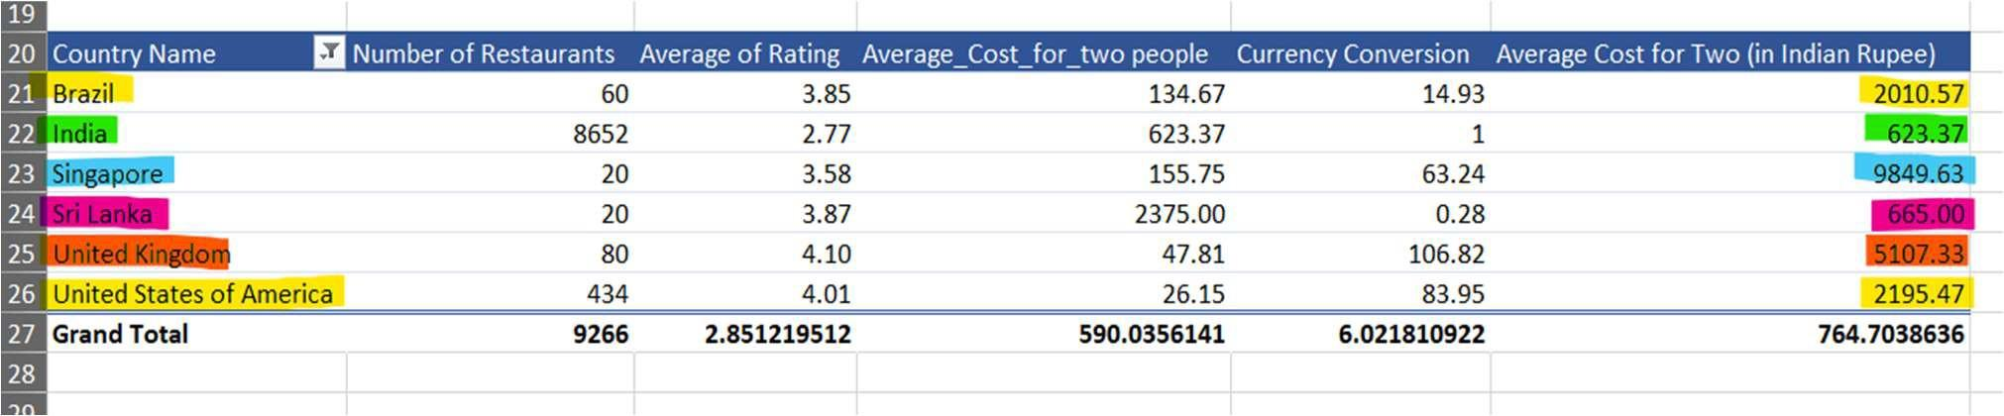

* + Average expenditure (in Indian Rupees) in the suggested cities such as **Brasí_lia, Ghaziabad, Singapore, Colombo, Birmingham, Dubuque** is as follows:

| **City, Country** | **No. of Restaurants** | **Average Cost for Two (Indian Rupees)** |
| --- | --- | --- |
| Brasí_lia, Brazil | 20 | **1791.6** INR ~ 120 (**B$**) |
| Ghaziabad, India | 25 | **602** INR |
| Singapore, Singapore | 21 | **9849.63** INR ~ 155.75 (**S$**) |
| Colombo, Sri Lanka | 20 | **665** INR ~ 2375 **LKR** |
| Birmingham, United Kingdom | 20 | **4165.98** INR ~ 39 (**Œ£**) |
| Gainesville, United States of America | 20 | **1783.94** INR ~ 21.25 (**$**) |

| *Country Name* | *City* | AVERAGE of Average_Cost_for_two | AVERAGE of average cost for two(in Indian Rupees) |
| --- | --- | --- | --- |
| Brazil | Brasí_lia | 120 | 1791.6 |
| India | Ghaziabad | 602 | 602 |
| Singapore | Singapore | 155.75 | 9849.63 |
| Sri Lanka | Colombo | 2375 | 665 |
| United Kingdom | Birmingham | 39 | 4165.98 |
| United States of America | Dubuque | 23.75 | 1993.8125 |
| **Grand Total** |  | **554.56** | **3074.9636** |

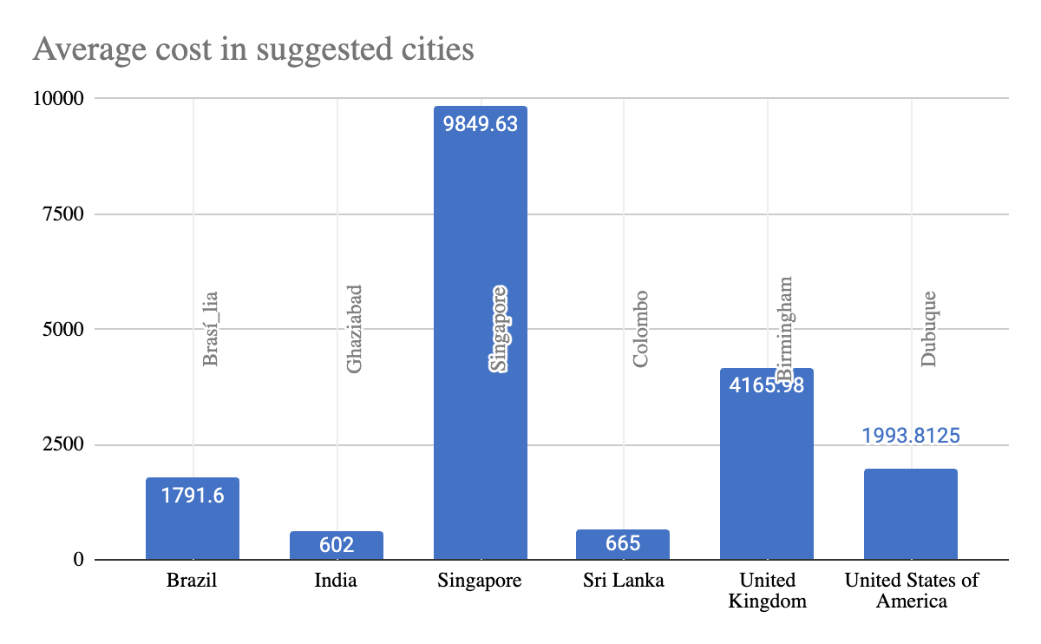



1. Come up with the names of restaurants from the recommended states that are our biggest competitors and also those that are rated in the lower brackets, i.e. 1-2 or 2-3.

Ans:

| **S.No.** | **Restaurant Name** | **City, Country** | **Number of**  **Restaurants** | **Average**  **Rating** | **Average_Co**  **st_for_two** | **Average Cost**  **for Two (INR)** | **Average Cost in**  **the City (INR)** |
| --- | --- | --- | --- | --- | --- | --- | --- |
| 1 | **Sandubas Cafí©** | Brasí_lia, Brazil | 1 | 1 | 30 | 447.9 | 1791.6 |
| 2 | **The Big Scoop** | Ghaziabad,  India | 2 | 1 | 250.00 | 250.00 | 602 |
| 3 | **Makansutra**  **Gluttons Bay** | Singapore,  Singapore | 1 | 3 | 30.00 | 1879.20 | 9849.63 |
| 4 | **Elite Indian**  **Restaurant** | Colombo, Sri  Lanka | 1 | 2.4 | 1800.00 | 560.00 | 665 |
| 5 | **Pepe’s Piri Piri** | Birmingham,  United Kingdom | 1 | 2.8 | 10.00 | 1068.2 | 4165.98 |
| 6 | **Burnt Toast Cafe** | Dubuque, United States of  America | 1 | 3.4 | 10.00 | 839.5 | 1993.81 |

| *Country Name* | *City* | *RestaurantName* | AVERAGE of Average_Cost_for_two | AVERAGE of Rating | AVERAGE of average cost for two(in Indian Rupees) |
| --- | --- | --- | --- | --- | --- |
| India | Ghaziabad | The Big Scoop | 250 | 1 | 250 |
| Brazil | Brasí_lia | Sandubas Cafí© | 30 | 1 | 447.9 |
| Sri Lanka | Colombo | Elite Indian Restaurant | 1800 | 2.4 | 504 |
| United States of America | Dubuque | Burnt Toast Cafe | 10 | 3.4 | 839.5 |
| United Kingdom | Birmingham | Pepe's Piri Piri | 10 | 2.8 | 1068.2 |
| Singapore | Singapore | Makansutra Gluttons Bay | 30 | 3 | 1897.2 |

The above selected restaurants can be considered as competitors in their respective cities as they have average cost per two lesser than the average cost of all the restaurants combined in the city.

For example, Elite Indian Restaurant in Colombo has an average cost equivalent to 602 INR whereas the average cost of all the restaurants in Colombo is 665 INR.



1. Which cuisines should we focus on in the newer restaurants to get better feedback? Does the choice of cuisines affect the restaurant ratings?

Ans:

* + Considering the top 10 cuisines, we can see that North Indian cuisine which is available in 945 restaurants has an average rating of 2.2, whereas restaurants with Street food cuisine is available at 149 restaurants with an average rating of 2.5.
  + From the visual below, we can conclude that the customer ratings have a major effect on the choice of cuisines.

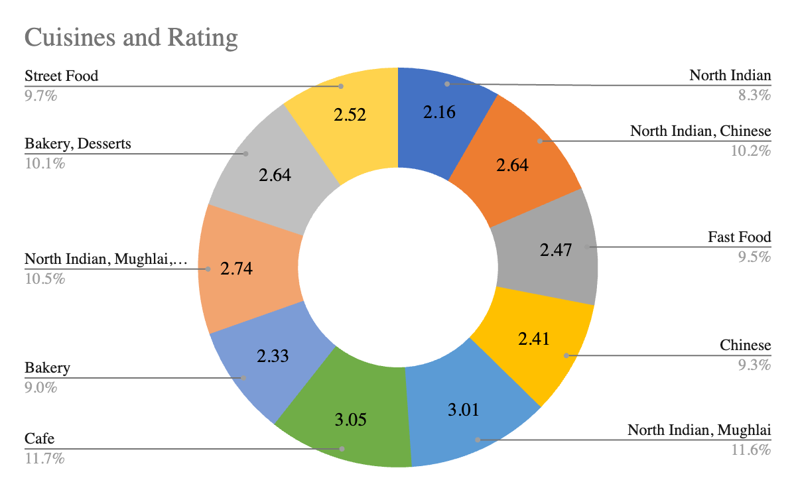

1. According to our current data, should we go for online delivery and table booking? Does that affect the customer’s ratings?

Ans: The online delivery and table booking definitely has an impact on the customer ratings across the globe. It would be better for the restaurants to have both table booking and online delivery in order to get better ratings from the customers.

| **S.No.** | **TABLE BOOKING** | **ONLINE DELIVERY** |
| --- | --- | --- |
| 1 |  |  |
| 2 | Chart | Chart |
| 3 | * From the above chart, we can see that restaurants offering table booking are less than the ones that do not offer table booking. * While opening a new restaurant in any of the suggested cities, table bookings can increase or decrease depending on the location / locality. | * Around 25-28% of the restaurants offer online deliveries and the average ratings are higher than the restaurants that do not offer online delivery. * On analysis for the suggested cities, online delivery can be done for countries like India where many restaurants offer the same. |



1. Should the team keep the rate of cuisines higher? Will that affect the feedback? According to our data are the rates of cuisines and ratings, correlated?

Ans:

* + The correlation value between rates of cuisines and customer ratings is 5%, which means that the rates of cuisines and ratings are not very much dependent. Inst

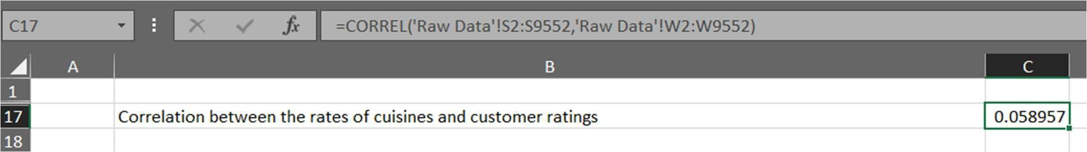

* + On further analysis by finding correlation between other numerical values, we can see that price range and customer ratings have the highest value.
  + It means that the price range has a great impact on the customer ratings.

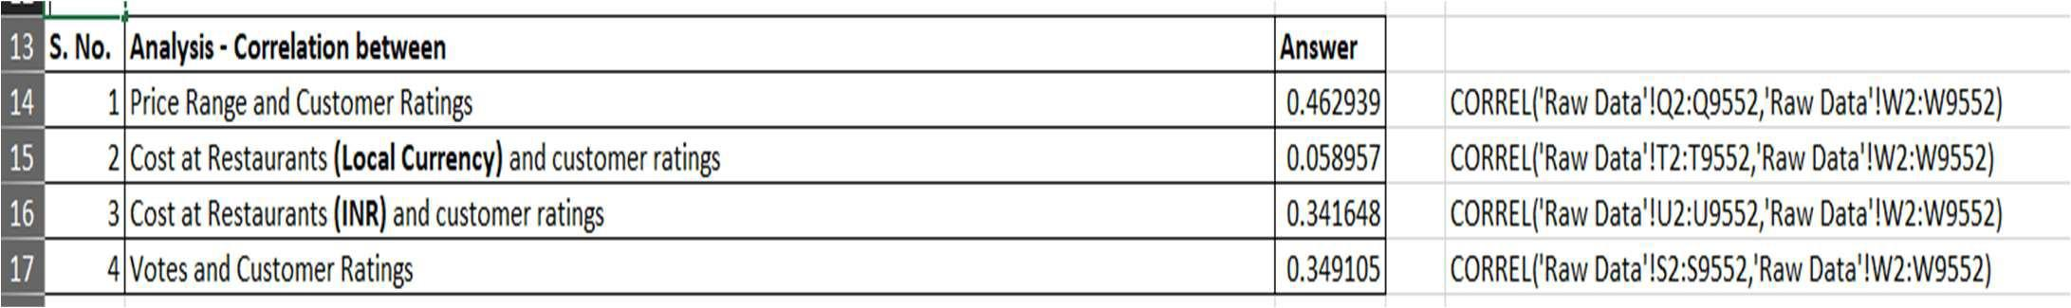

## Recommendation:

* + It is important to determine the price range of the restaurant to be opened which will directly impact the customer ratings.



1. What is the distribution of the number of restaurants of different price ranges in all the countries?

Ans: The distribution of restaurants with price ranges from 1 to 4 is as follows:

* + Price Range 1 – 4444 (46.53%)
  + Price Range 2 – 3113 (32.60%)
  + Price Range 3 – 1408 (14.74%)
  + Price Range 4 – 586 ( 6.13%)
* We can observe that most of the restaurants fall in the price range 1 which means that there are high chances of a restaurant being opened in the future under the price range 1.

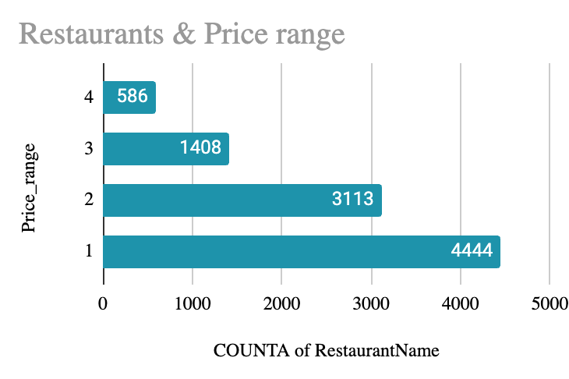



1. Explain your approach in brief for suggesting countries/cities in order to open new restaurants, if the objective and subjective questions would have not been given to assist you.

Ans:

## Approach and the steps for dashboard creation:

* + Firstly, data has to be checked for inconsistencies by handling missing values and removing duplicate values.
  + Create new columns from existing columns if needed for analysis. Eg) Extracting year from date to find number of restaurants being opened yearwise.
  + Check for correlations between numerical values and do the analysis accordingly.
  + See if any parameters can be forecasted. In the excel file, I have forecasted the price ranges as well as the number of restaurants that can be opened in the future.
  + Categorize the ratings as they cannot be visualized properly, the reason being too many values ranging from 1.0 to 4.9.
  + Create the dashboard with the required visuals like KPIs, Timeline, Slicers, Column charts, line charts, Pie Charts etc.

## Questions not addressed in subjective and objective questions:

* + Comparing the number of restaurants according to the rating category
  + Ratings in accordance with the total votes
  + Forecasting the number of restaurants being opened in the future
  + Price Range forecast in case if a new price range pops up

